ELEG 312 - Example Problems Chapter 9-1

**Example 9.1**

For the MOS differential pair with a common-mode voltage *VCM* applied, as shown in Fig. 9.2, let *VDD = VSS* = 1.5 V, *k’n*(*W/L)* = 4 mA/V2, *Vt* = 0.5 V, *I=* 0.4mA, and *RD* = 2.5 k, and neglect channel-length modulation. Assume that the current source *I* requires a minimum voltage of 0.4 V to operate properly.

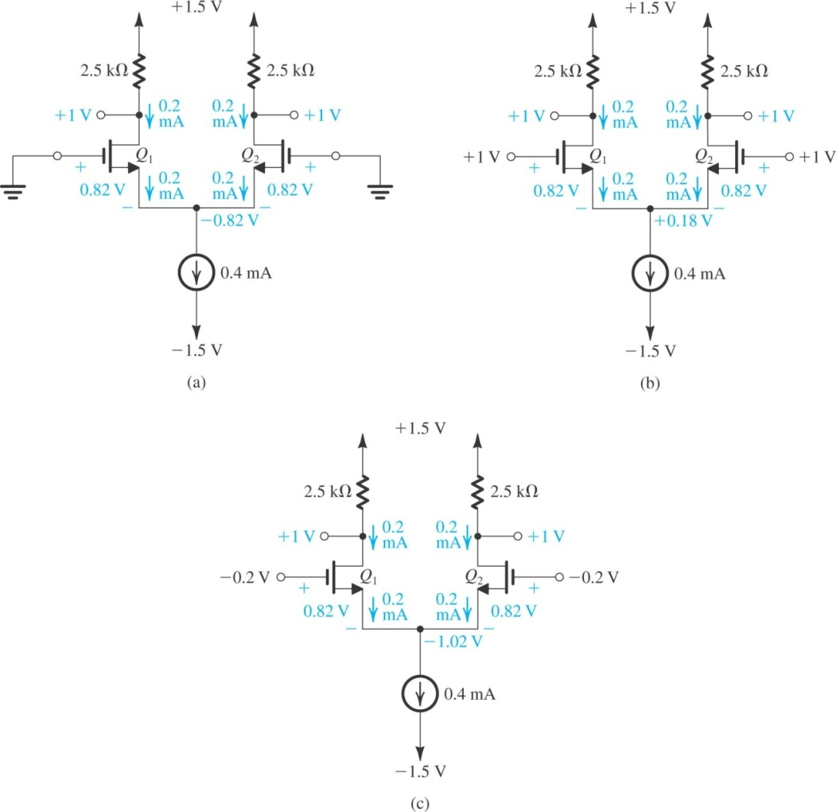

(a) Find *VOV* and *VGS* for each transistor.

(b) For *VCM* = 0, find *VS, ID*1*, ID*2*, VD*1, and *VD*1.

(c) Repeat (b) for *VCM* = +1 V.

(d) Repeat (b) for *VCM* = - 0.2 V.

(e) What is the highest permitted value of *VCM*?

(f) What is the lowest value allowed for *VCM*?

**Example 9.2**

Give the differential half-circuit of the differential amplifier shown in Fig. 9.11(a). Assume that *Q*1 and *Q*2 are perfectly matched. Neglecting *ro*, determine the differential voltage gain *Ad* = *vod*/*vid*.

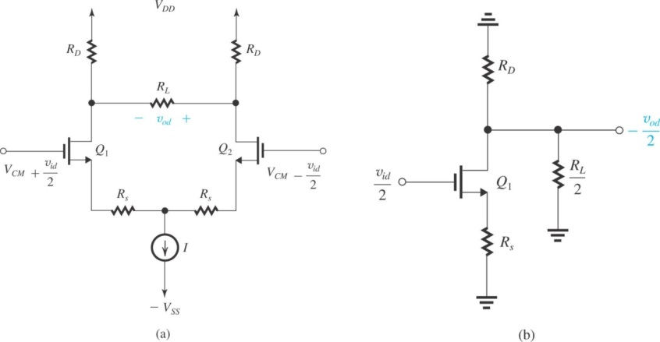 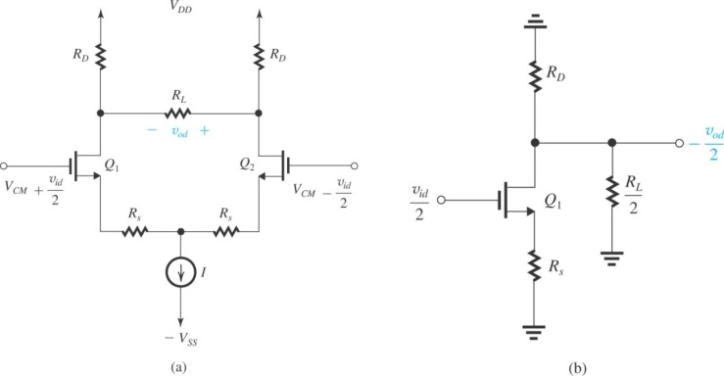

**Exercise 9.7**

Find *vE, vC*1*,* and *vC*2in the circuit of Fig. E9.7. Assume that *|vBE|* of a conducting transistor is approximately 0.7 V and that * ≈* 1 *.*

